Prima Donna AI iOS App Handoff
Prepared: June 14, 2026
Target platform: Native iPhone app
Recommended implementation: SwiftUI, MVVM, Supabase Auth/REST, Supabase Edge Functions
Reference repository: https://github.com/david54766/hello2-greeting-page.git
Reference branch: codex/android-native-migration

1. Initial Prompt For The Mac Build
Use this prompt to start the iOS implementation on the Mac:
Build a native iOS iPhone app for Prima Donna AI. Use SwiftUI and Xcode. Match the attached five screenshots as the visual styling guide: rose off-white background, serif editorial headlines, magenta accent, rounded white cards, fixed bottom tab bar, crown Elite tab, and compact operator workflows.

Recreate the current mobile feature set natively for iPhone: login, temp sign-in for debug builds, Home center snapshot, Coaching Engine with Raven strategy responses and voice playback, Template Vault, Elite Circle conversations/schedule, Settings with current plan only, and Supabase-backed data.

Do not include Stripe billing. Do not expose OpenAI, ElevenLabs, Supabase service-role, Resend, or Stripe secrets in the app. The iPhone app may use the Supabase publishable/anon key only. All AI, Raven voice, protected downloads, and server operations must go through Supabase Edge Functions.

Use the attached screenshots as the styling source of truth. If there is a conflict between generic iOS defaults and the screenshots, follow the screenshots.
Security note: do not paste live passwords, OpenAI keys, ElevenLabs keys, Supabase service-role keys, Resend keys, or Stripe secrets into the repo, Xcode project, screenshots, or this document. Keep credentials in the Mac keychain, local .xcconfig, or Supabase secrets.

2. Product Goal
Create a native iPhone version of Prima Donna AI that feels like the mobile screenshots, not like a web view. The app should share the same backend and product behavior as the current mobile build, while using native SwiftUI controls, native navigation, native audio playback, and iOS-safe credential handling.
Stripe billing is intentionally excluded. The app should only show the current membership tier/status in Settings.

3. Styling Source Of Truth
The five attached screenshots are the visual guide:
01-login.jpg: sign-in layout and brand treatment.
02-elite.jpg: Elite Circle conversations and bottom tab styling.
03-vault.jpg: Template Vault filters, cards, badges, and download actions.
04-coach.jpg: Coaching Engine prompt layout and previous strategies entry.
05-home.jpg: Home dashboard center snapshot and strategic recommendation card.
Use these screenshots to match spacing, hierarchy, color, typography, tab behavior, and card geometry.

4. iOS Architecture
Use a straightforward native structure:
PrimaDonnaAIApp: app entry point and environment injection.
AppState: global auth/session/user/tier state.
AuthStore: sign-in, sign-out, password reset, temp sign-in for debug builds.
SupabaseClient: typed wrapper around Supabase Auth and REST calls.
MobileApiClient: typed wrapper around Supabase Edge Function mobile-api.
AudioPlaybackService: plays Raven voice responses from returned audio bytes or URLs.
SpeechInputService: optional iOS speech-to-text support for the Speak button.
DownloadService: opens or downloads protected Vault assets.
ViewModels: one view model per screen for loading, submitting, and error state.
Views: SwiftUI screens/components.
Recommended folder shape:
iOS/PrimaDonnaAI/
PrimaDonnaAIApp.swift
Config/
AppConfig.swift
Secrets.xcconfig.example
Models/
UserProfile.swift
Center.swift
Subscription.swift
VaultItem.swift
StrategySession.swift
EliteConversation.swift
Services/
AuthStore.swift
SupabaseClient.swift
MobileApiClient.swift
AudioPlaybackService.swift
SpeechInputService.swift
DownloadService.swift
ViewModels/
LoginViewModel.swift
HomeViewModel.swift
CoachViewModel.swift
VaultViewModel.swift
EliteViewModel.swift
SettingsViewModel.swift
Views/
LoginView.swift
MainTabView.swift
HomeView.swift
CoachView.swift
VaultView.swift
EliteView.swift
SettingsView.swift
Components/
Do not directly port Jetpack Compose code. Use the Android app as a behavior reference and the screenshots as the visual reference.

5. Local Mac Setup
Clone the GitHub repo:
- git clone https://github.com/david54766/hello2-greeting-page.git
- cd hello2-greeting-page
git checkout codex/android-native-migration
Create a new native iOS Xcode project or workspace under iOS/PrimaDonnaAI.
Add local configuration through an uncommitted .xcconfig file:
- SUPABASE_URL=https://owjhaoiqiujpdndcwccl.supabase.co
- SUPABASE_ANON_KEY=<publishable-or-anon-key>
- WEB_APP_URL=https://app.thepreschoolprimadonna.com
- AUTH_REDIRECT_URL=preschoolprimadonna://auth-callback
- QA_EMAIL=<debug-temp-login-email>
QA_PASSWORD=<debug-temp-login-password>
Add Secrets.xcconfig to .gitignore.
Keep server secrets only in Supabase:
- OPENAI_API_KEY
- ELEVENLABS_API_KEY
- RAVEN_VOICE_ID
- RESEND_API_KEY
RESEND_FROM_EMAIL
The Raven voice ID is already known by the backend and should not be hardcoded in UI code unless the backend contract specifically requires it.

6. Backend Contract
The iOS app should call Supabase directly only for safe client operations:
Supabase Auth sign-in, sign-out, password reset.
Read/write rows allowed by RLS using the publishable/anon key.
Fetch current profile, centers, subscription status, visible Vault records, and visible Elite conversations.
The iOS app should call Supabase Edge Function mobile-api for protected or server-side work:
Action | Client Input | Result
run_coaching | mode, prompt, selected center | strategy title, strategy body, session id, created date
synthesize_raven_voice | strategy text or session id | playable audio payload or audio URL
generate_daily_recommendation | center id | daily recommendation card data
get_secure_vault_asset | vault item id | signed download URL or safe open URL
book_with_raven | user/profile context | booking URL or schedule route

OpenAI and ElevenLabs must never be called directly from the iPhone app.

7. Core Models
Define typed Swift models that mirror backend rows and API responses.
struct UserProfile: Identifiable, Codable {
let id: UUID
var displayName: String
var email: String
var tier: MembershipTier
}

enum MembershipTier: String, Codable {
case essentials
case pro
case elite
}

struct Center: Identifiable, Codable {
let id: UUID
var name: String
var city: String?
var state: String?
var enrollment: Int?
var monthlyRevenue: Decimal?
var facilityGoal: Int?
}

struct StrategySession: Identifiable, Codable {
let id: UUID
var mode: String
var prompt: String
var response: String?
var createdAt: Date
}

struct VaultItem: Identifiable, Codable {
let id: UUID
var title: String
var summary: String
var category: String
var tier: MembershipTier
}
Use Decimal for currency internally and format with NumberFormatter or Swift's currency formatting.

8. Shared Layout Tokens
Match the screenshots with these tokens:
Token | Value
Screen background | Rose off-white, approximately `#FFF7FA
Card background | White, `#FFFFFF
Primary accent | Logo magenta, approximately `#E90092
Selected chip fill | Soft lavender, approximately `#EFE2FF
Selected nav fill | Soft pink, approximately `#FFD7EE
Gold badge fill | Cream/gold, approximately `#F8F0E3
Gold badge text | Muted gold, approximately `#B58B44
Border | Warm gray/pink, approximately `#E6DDE2
Primary text | Near black, approximately `#161316
Secondary text | Warm gray, approximately `#5F5860
Horizontal page margin | 24 pt on standard iPhone width
Card radius | 8 to 14 pt for content cards; 28 to 32 pt only for login card
Button radius | Capsule
Bottom tab height | Respect safe area, fixed bottom surface

Typography guidance:
Large page titles should feel editorial and serif. Use a bundled brand font if available. Otherwise use Font.system(.largeTitle, design: .serif) with a light/regular weight.
Labels, chips, buttons, and card content should use system sans-serif.
Section eyebrows are uppercase, magenta, bold, and tightly spaced.
Avoid shrinking text with viewport width. Prefer wrapping or horizontal chip scrolling.

9. Navigation
Use a native TabView with five tabs:
Tab | Label | Icon
Home | Home | house
Coach | Coach | text bubble
Vault | Vault | folder
Elite | Elite | crown
Settings | Settings | gear

Do not include Billing or Plan as a tab. Billing should be removed from the app surface. Current plan belongs in Settings only.
Top bar:
Center the Prima Donna logo with AI text beside it.
Use a logout icon on the right.
On screens that still need refresh, keep it subtle. The current screenshot set shows only logout on most iPhone views.
Keep top content inside the iOS safe area.

10. Screen Instructions

Login
Match 01-login.jpg.
Requirements:
Rose off-white full-screen background.
Centered brand logo and AI at top.
White rounded sign-in card with soft shadow.
Title: Sign in.
Subtitle: Access your private AI command center.
Email and password fields in rounded white inputs with soft borders.
Forgot password? magenta text aligned right.
Primary button text: Enter Command Center; disabled state is pale gray.
Debug-only secondary button: Temp sign in.
Footer text: Prima Donna AI.
Remove the old Sign in/Create toggle buttons. The form is the sign-in screen.

Home
Match 05-home.jpg.
Requirements:
Background remains rose off-white.
Show Center snapshot title.
Place membership badge on the upper-right, aligned with the title baseline area.
Center pill below title, for example PRIMA DONNA ACADEMY - MIAMI.
Snapshot cards:
- Enrollment
- Est. monthly revenue
- Facility goal
If there are multiple centers, use side swipe between center snapshots. Do not stack all centers vertically.
Keep the first viewport focused on the snapshot and recommendation. Avoid unnecessary vertical scrolling when data fits.
Recommendation section:
- Title Today's strategic recommendation.
- White card: Raven daily brief.
- Copy: Open the latest published Raven insight from... or actual current insight summary.

Coaching Engine
Match 04-coach.jpg.
Requirements:
Eyebrow: COACHING ENGINE.
Large serif title: Open a strategic session.
Horizontal mode chips:
- CEO
- Revenue
- Marketing
- Compliance
- Systems
Selected chip uses soft lavender fill.
Under chips show the selected mode subtitle, for example Vision - Leadership - Decisions.
White prompt box with placeholder What's the situation?.
Prompt box must be white, not rose.
Buttons:
- Speak with microphone icon.
- Move with paper-plane/send icon; disabled until prompt exists.
- Previous strategies below those buttons, tightened and polished as a compact capsule button.
Previous strategy drawer/sheet:
- Should open as native sheet or bottom sheet.
- Show previous sessions as compact cards.
- Include Details and Play.
- Remove any Use/reuse prompt button.
Strategy result modal:
- Rose off-white modal background.
- Badge for mode.
- Title Strategy ready.
- Body text from OpenAI response.
- Date pill.
- Buttons: Close and Open strategy.
Raven voice playback:
- Strategy result and previous sessions must be playable in Raven voice.
- Use backend synthesize_raven_voice; play with AVAudioPlayer.

Template Vault
Match 03-vault.jpg.
Requirements:
Eyebrow: TEMPLATE VAULT.
Large serif title: The systems behind the strategy.
One-line horizontal category filter. Do not wrap chips to a second row.
Categories:
- All
- Enrollment
- Hiring
- Operations
Cards:
- White card background.
- Pink/gold rounded badges instead of plain text labels.
- Bold title.
- Summary body.
- Details button.
- Download action with download icon and magenta text.
Respect tier access. Pro and Elite badges should display as badges.

Elite Circle
Match 02-elite.jpg.
Requirements:
Default tab is Conversations, not Overview.
Eyebrow: ELITE CIRCLE.
Large serif title: Welcome to the room.
Two chips:
- Conversations
- Schedule
Book with Raven capsule button below chips; takes user to booking/schedule flow.
Latest conversations list:
- White cards.
- Title, author/team/date, message excerpt.
- Replies count.
- Open button with icon.
- Delete icon where allowed.
Schedule view should show upcoming/past booking state and a clear booking entry.

Settings
Requirements:
Show profile information.
Show current membership tier/status.
Show centers and allow add/edit center.
Show notification preferences if implemented.
No Billing page, no Plan tab, and no Stripe checkout surface.
Add center form:
Use the same card/input styling as login and settings cards.
Fields:
- Center name
- City
- State
- Ages served
- Enrollment
- Capacity or facility goal
- Tuition range
- Staff
- Notes/context for AI
Use clean two-column rows only where iPhone width supports them without cramped labels. Otherwise stack.

11. Function Checklist
Build or verify these functions on iOS:
Area | Function
Auth | Email/password sign-in
Auth | Forgot password
Auth | Sign out
Auth | Debug temp sign-in, excluded or disabled for release
Home | Fetch profile, tier, centers, center snapshot
Home | Swipe between centers
Home | Fetch or open Raven daily brief
Coach | Select strategy mode
Coach | Capture typed prompt
Coach | Optional speech-to-text into prompt
Coach | Submit prompt to `run_coaching
Coach | Save returned session
Coach | Open result modal
Coach | Fetch previous strategies
Coach | Play Raven voice for strategy response
Vault | Fetch visible Vault items
Vault | Filter by category
Vault | Show category and tier badges
Vault | Open details
Vault | Download/open protected asset
Elite | Fetch conversations
Elite | Open conversation
Elite | Delete conversation where allowed
Elite | Open booking/schedule
Settings | Read current plan
Settings | Read/add/edit centers

12. Native iOS Services
Use these Apple frameworks:
SwiftUI for screens/components.
Combine or Swift concurrency for state and async loading.
URLSession for Supabase REST and Edge Function calls.
AVFoundation for Raven audio playback.
Speech framework only if the Speak button will transcribe user voice into the prompt.
SafariServices or ASWebAuthenticationSession for external booking/auth flows if needed.
Use Swift Package Manager for third-party dependencies only when they reduce real work. Keep the dependency surface small.

13. Error And Loading States
Every screen should handle:
First load skeleton or quiet progress state.
Empty state with useful next action.
Network failure.
Expired session.
Permission/RLS denial.
Disabled action state.
Audio loading and playback failure.
Do not show raw backend errors to end users. Log the technical detail in debug builds and show short, human text in UI.

14. QA Checklist
Run on a small and large iPhone simulator plus one real iPhone if available.
Check:
Cold start lands correctly based on session state.
Login card matches screenshot spacing and centered logo.
Bottom tab bar respects safe area.
No text overlaps on smaller iPhone widths.
Vault chips remain one-line horizontal scroll.
Coaching prompt box is white.
Previous strategies button is compact and below Speak/Move.
Home snapshot does not unnecessarily scroll when content fits.
Multiple centers swipe horizontally.
Elite defaults to Conversations.
Billing/Plan tab is absent.
Current plan appears only in Settings.
Raven voice plays from strategy result and previous strategies.
No OpenAI, ElevenLabs, service-role, or Stripe secret is present in the iOS app bundle.

15. Release Notes For The Mac Builder
Treat this as a native iPhone app build, not a web wrapper.
Use the Android implementation only as behavior reference.
The attached images are the visual contract.
Keep Stripe out for now.
All server-side AI and voice work goes through Supabase Edge Functions.
Store local dev credentials in an ignored .xcconfig file.
Before TestFlight or App Store release, remove or gate temp sign-in behind debug-only compilation.

16. Handoff Assets
The Word/PDF version of this document embeds all five sample screens. The raw images are also included in handoff-ios/assets:
01-login.jpg
02-elite.jpg
03-vault.jpg
04-coach.jpg
05-home.jpg

iOS Styling Reference Screens

1. Login screen
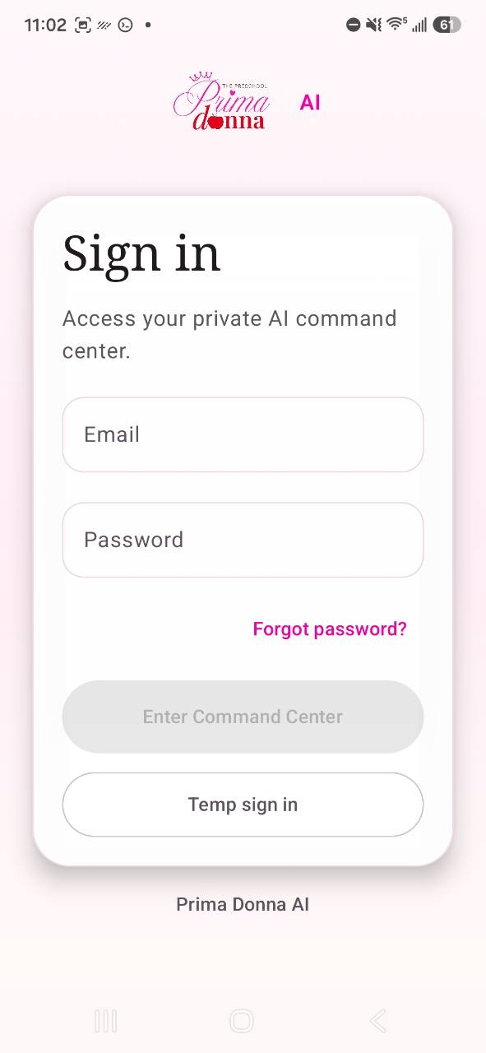

2. Elite Circle conversations
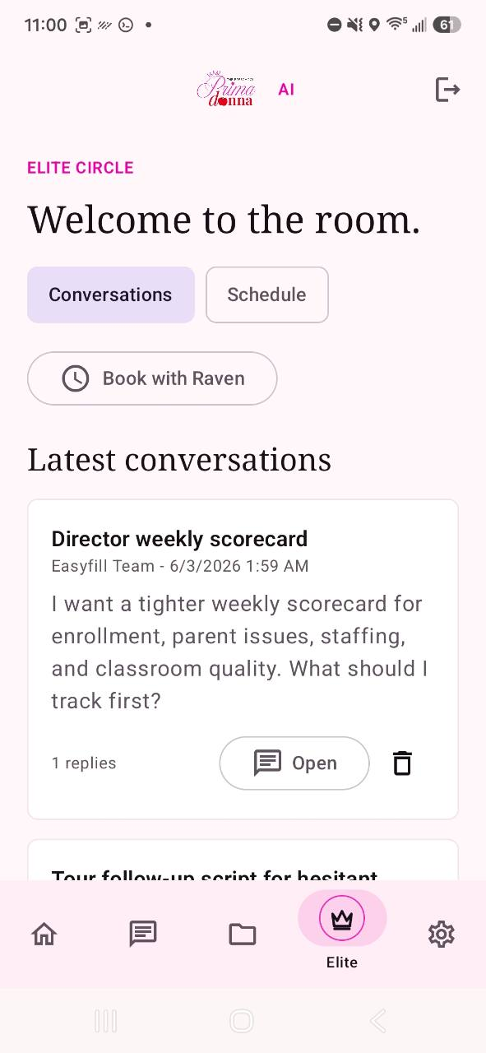

3. Template Vault
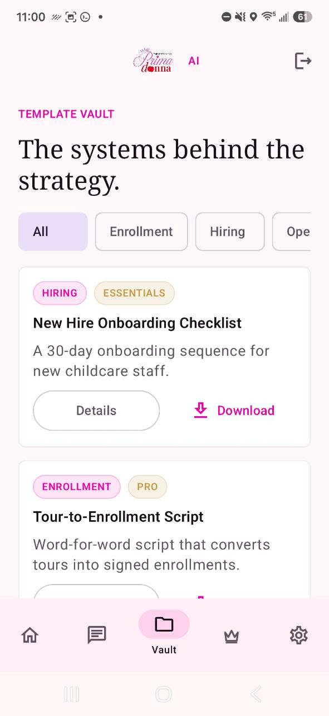

4. Coaching Engine
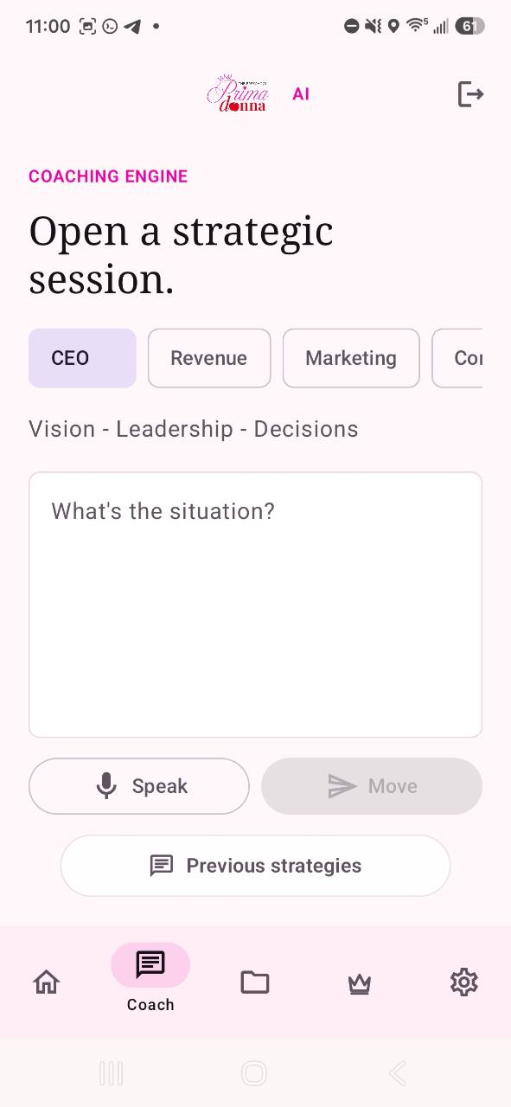

5. Home center snapshot
